Proposed Connection

Class(Subject)

User(Teacher) Session

Problems Statement :
1. Currently a session is generated randomly without any connection to the subject/class
2. Classes(subjects) are assigned to teachers, when in reality teachers should be assigned to each class/subject.(As a single subject can have multiple teachers)
So the hierarchy should look like this:
Class (Subject)
↓
User (Teacher)
↓
Session (Attendance Instance)

Proposed Solution :

We give the Teacher the option to select the subject first before creating a session

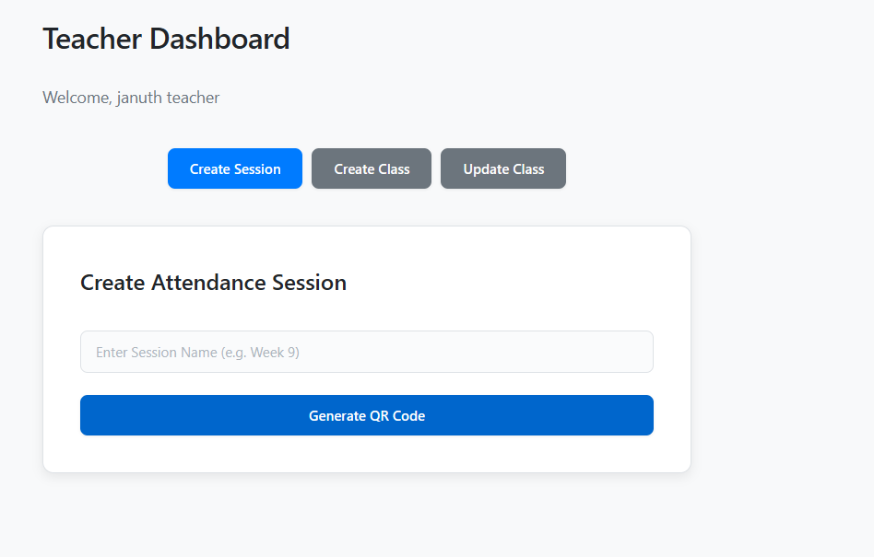
Add a dropdown here, listing the classes available to each teacher.
After selecting a subject the “Session Name” field will be enabled and the teacher can go ahead with creating a session

This Session Name field should be initially disabled until the subject/class is selected from the dropdown

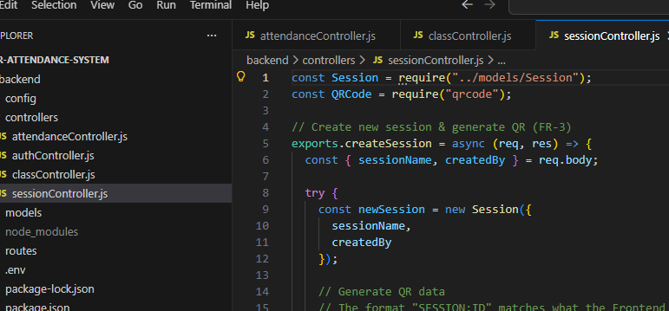
Need to add another variable for Class ID,
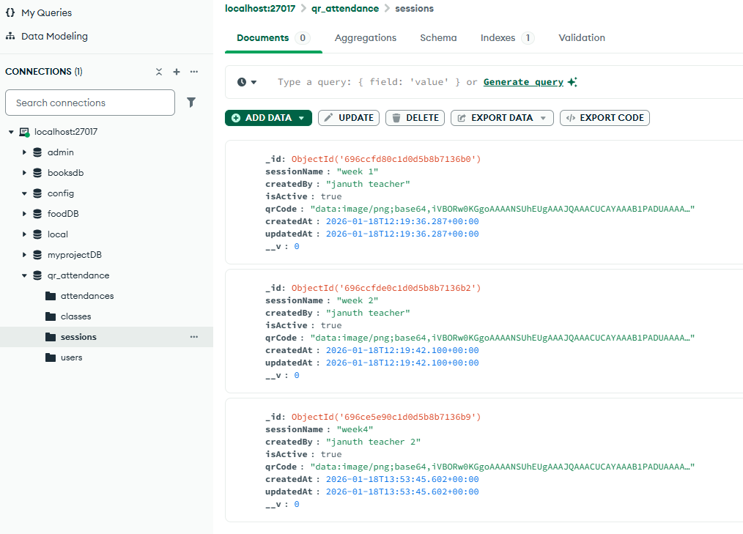

There needs to be some extra variables in DB for a “session”:

{
_id,
sessionName,
createdBy,
classId: Class ObjectId, // links the session to a class
teacherId: Teacher ObjectId, // we have createdBy, but better to add the teacher ID as well
isActive,
qrCode,
createdAt,
updatedAt
}

